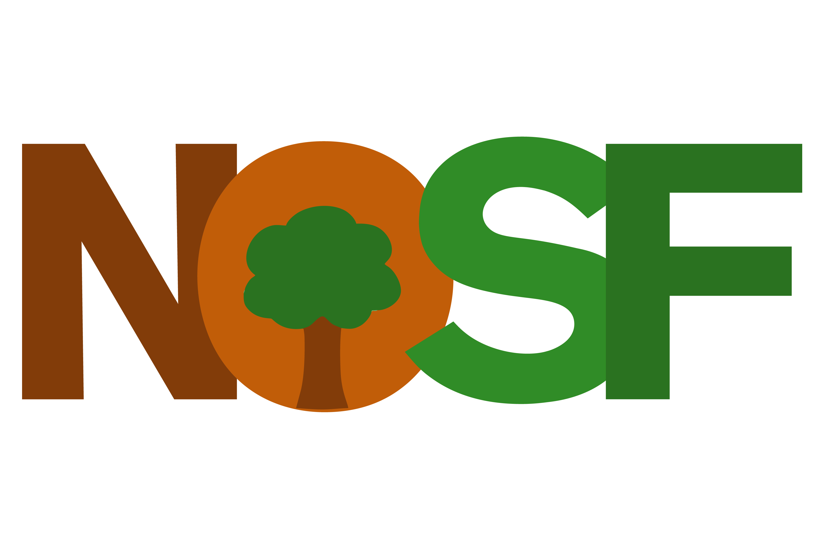

Nottingham Open Spaces Forum is an independent charity which brings together Friends of Groups, other volunteers, community gardeners, partner organisations and other stakeholders to create a support network. We aim to work together and in partnership with Nottingham City Council and other public landowners to promote, protect, conserve and enhance the open and green spaces of our City.

The charity’s objects are:

- To advance the education of the public in the enjoyment, understanding, application and conservation of open spaces within the city of Nottingham.
- To promote for the benefit of the public the conservation, protection and improvement of the physical and natural environment (including parks, play areas, sports fields, allotments, nature reserves, woodlands and cemeteries) within the City of Nottingham
- To enhance public health and wellbeing through access to and activity in open spaces

www.nosf.org.uk

https://www.facebook.com/NottinghamOSF

nottinghamosf@gmail.com

Charity registration number: 1176727
Registered office: Browne Jacobson LLP, Mowbray House, Castle Meadow Road, Nottingham, NG2 1BJ

We will support the maintenance and improvement of the City’s Open Spaces by:

- Lobbying government to formulate and implement appropriate national policies.
- Raising funds to supplement public funding.
- Raising public awareness of the importance and public benefit of open spaces
- Working together with Friends Groups, encouraging them to work with each other, helping to create new Groups, growing the network by involving previously separate groups, assisting groups with sustainability.
- Liaising with other organisations with similar objectives in Nottingham.
- Encouraging Area Committees to expend funds available to them on open spaces in their area.
- Overseeing the City Council`s open spaces policies and making representations when necessary to ensure that all Council departments and Nottingham City Homes are committed to these and their implementation.
- Affiliating to and working with the appropriate Regional & National bodies.

We will provide the following benefits to our members:

- Providing group insurance, either through a City Council scheme or another insurance company.
- Providing banking facilities for groups.
- Assisting with bids for grants.
- Providing templates for operating policies required by statute or good practice.
- Organising training events.
- Using the Forum`s charitable status to gain financial and other benefits for members.
- Providing a database of potential funding sources.
- Developing systems for shared communications.
- Producing a regular newsletter.
- Organising events and visits.

To implement this manifesto we will:

- Providing an efficient core secretariat and organisation to implement this manifesto.
- Develop links with all parts of the media.
- Appoint an enthusiastic and skilled board of trustees to formulate policy, inspire and steer.

